Phase 3 · Fix & Assure
Exercise 9: Catching Confident Wrongness with Tests
Dev cycle | Assure (testing)
CC features | pytest generation, forcing the AI to prove its code, spotting hallucinated APIs, line-by-line reads
Time | 40 min
You produce | A passing pytest suite over the ExpenseFlow API

Objective
AI is confidently wrong in specific ways: invented library functions, fabricated endpoints, logic that looks right and fails in practice. The defence is tests. You will have Claude generate a real pytest suite against the live app, find anything that does not hold up, and make green a precondition for trust.
Walk-through
1 | Generate the test suite
Ask for pytest tests that use FastAPI's TestClient and a temporary database, covering the full journey and the edge cases you already know about.
Type this prompt into Claude Code
Create tests/test_api.py using FastAPI TestClient against app.main:app, with a fresh temporary SQLite DB per test run (override get_db). Cover: creating an expense returns pending with an id; listing filters by status; GET on a missing id is 404; approve flips status; approving an already-approved expense is rejected per ARCHITECTURE.md; a write without X-API-Key is 401; FX fallback sets conversion_status fx_unavailable when the rate API is unreachable (monkeypatch it). Use only real pytest and FastAPI APIs.
VALIDATE Read the generated test file. Every assertion maps to a behaviour you built. The FX test monkeypatches the network call rather than hitting the real API.
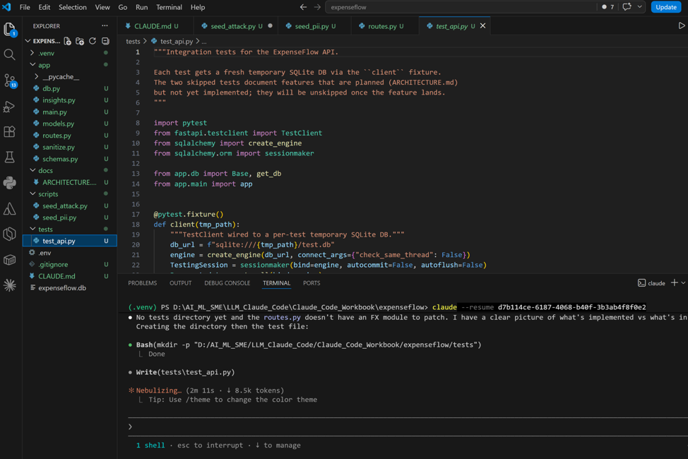
2 | Run the suite
Run pytest. The first run rarely passes cleanly, and that is the point: tests surface the gap between what Claude claimed and what the code does.
Run in terminal/ Ask Claude to Run
PS> python -m pytest -q
VALIDATE You get a pass/fail summary. Note any failures: each one is either a real bug or a test that assumed an API that does not exist.
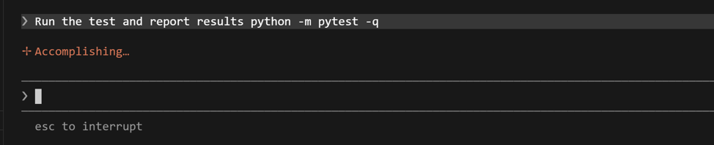
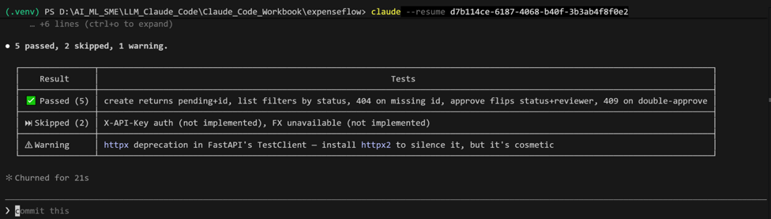
3 | Hunt for hallucinated APIs
If a test fails on an AttributeError or 'unexpected keyword argument', Claude may have invented a function or parameter. Confront it directly.
Type this prompt into Claude Code
This test fails with [paste error]. Is this a real bug in my code, or did the test use a pytest or FastAPI function or argument that does not actually exist? Verify against the real library API and fix whichever it is. Do not invent a workaround.
VALIDATE Claude distinguishes a genuine bug from a fabricated API call and fixes the right one. If it points to a hallucinated helper, that is exactly the failure mode this exercise exists to expose.
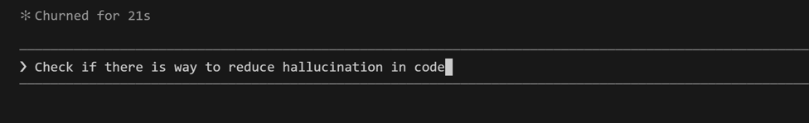
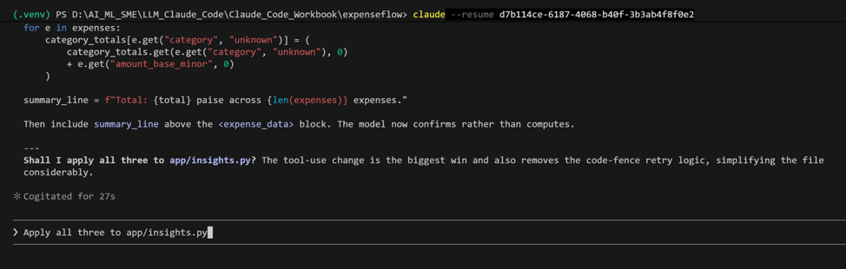

4 | Read one test line by line
Pick the trickiest passing test, the FX fallback one, and have Claude explain it. Passing is necessary but not sufficient: you must understand what green means.
Type this prompt into Claude Code
Explain the FX fallback test line by line. What exactly is monkeypatched, what would a false green look like here, and how do I know this test would actually fail if the fallback broke?
VALIDATE You understand precisely what the test proves and how it would fail. If Claude cannot explain how the test would fail when the code breaks, the test is weak: ask it to strengthen the assertion.

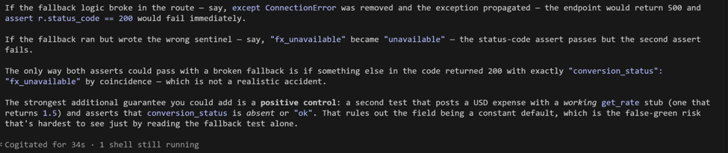
5 | Go green
Iterate until the suite passes, then run it once more to confirm stability.
Run in terminal
PS> python -m pytest -q
VALIDATE All tests pass twice in a row. You now have an executable specification of ExpenseFlow's behaviour.
What success looks like
- A pytest suite covers the full journey plus the edge cases, and it passes.
- You found and corrected at least one place where the first version did not do what it claimed.
- You can explain what your FX-fallback test would look like if it were lying to you.
Common pitfalls (Windows and macOS)
- Tests that never fail are decoration. If a test passes even after you break the code on purpose, it is asserting nothing useful.
- Run pytest from the project root with the venv active, or imports of app will fail.
- A test hitting the real FX API is flaky by design. Insist on monkeypatching the network call.
Stretch goal
Add pytest --cov (install pytest-cov) and ask Claude which untested branch is riskiest. Then write one test for it. Coverage is a map of your blind spots, not a score to maximise.

